1. CMD as **run as administrator**
2. Enter netstat -a -o -n and hit enter. Now you can see like below. Port can see **Local Address** column after **:** sign.

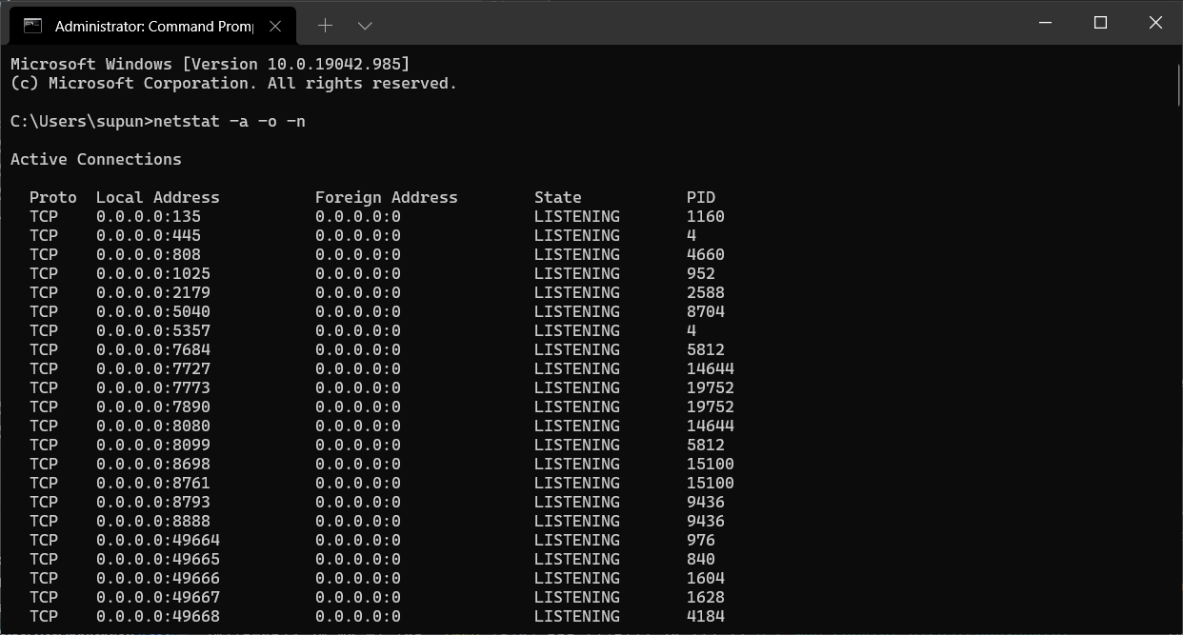

1. select the process id(not port) that your port running and type taskkill /F /PID <process_id_here> command and hit enter.

[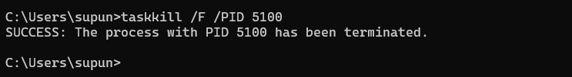](https://i.stack.imgur.com/nQIXT.png)